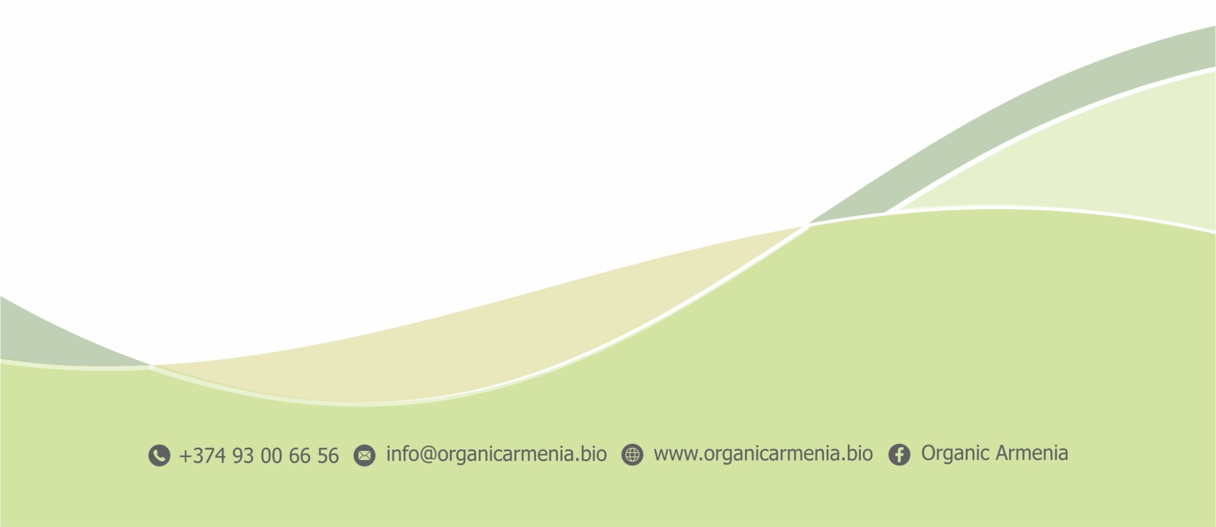
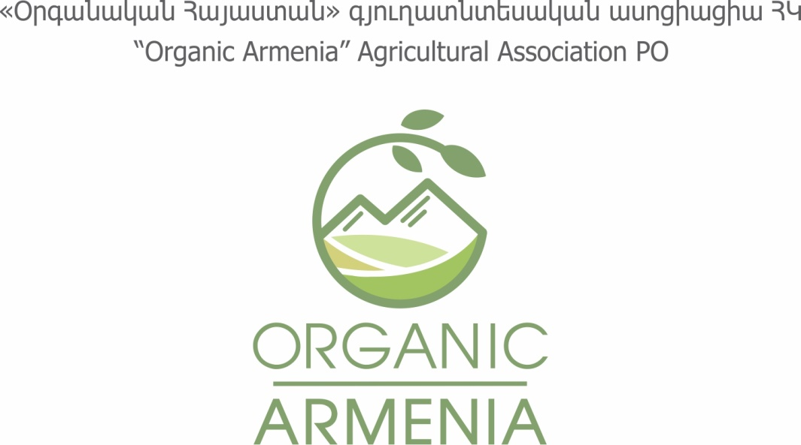
APPLICATION
We are glad to greet you as a member of the newly formed “ORGANIC ARMENIA” ASSOCIATION. To register your membership, please provide the following information:

Membership status |  | Monthly fee
 | Applying as a legal entity** | 5 000  (60 000 AMD/year)
 | Applying as an individual (individually)* | 2 500  (30 000 AMD/year)
* For full members

“Certified organic” production
Organic certificate code: …………………

“Transitional certified organic” production
Transitional organic certificate code:………

Company name | ……………………………………………………………..…………………………
Type | Commercial (e.g. company, etc.)  Non-profit (e.g. NGO, etc.)
Sphere of activity | Production Processing Sorting  Contributions  Services Consultancy Education  Other (specify)..…………………………………………………………….
State registration number | ……………………………………………………………..…………………………
Name and last name of contact person | ……………………………………………………………..…………………………
Address | ……………………………………………………………..…………………………
 | ……………………………………………………………..…………………………
Phone | ……………………………………………………………..…………………………
E-mail | ……………………………………………………………..…………………………
Website | www……………………………………………………..……………………………

With this signature I give my consent to membership in “Organic Armenia” Association.

Date………………………… Signature ………………………………………

This application will come into force after the payment is done.
Within 30 working days from the date of signing of the application an invoice will be sent, according to which the payment shall be done in cash or via bank transfer.
Membership is possible only in case of yearly subscription; the yearly payment shall be done on a one-time basis.

